Transbnk GCP Enviorment

Networking

VPC -
One VPC network created with 6 subnets

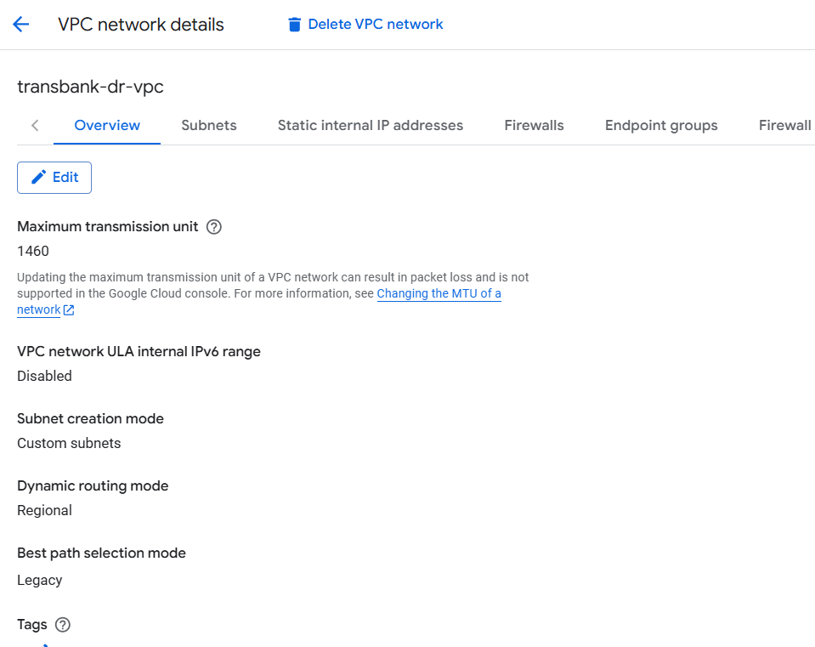

Subnets -
- 6 subnets created in asia-south-1 region with a range of 172.20.0.0/20
- 3 private subnets and 3 public subnets

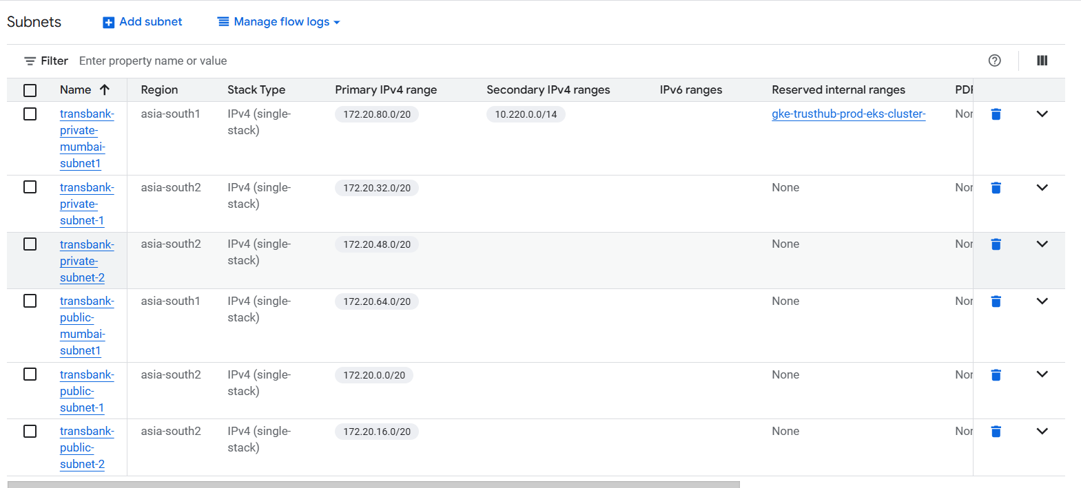

Docker images migration
- Migrated AWS ECR repositories to Google Cloud Artifact Registry
- Used a custom migration script
- The script creates new repositories in GCP
- Migrated all Docker images
- Preserved all image tags during the migration
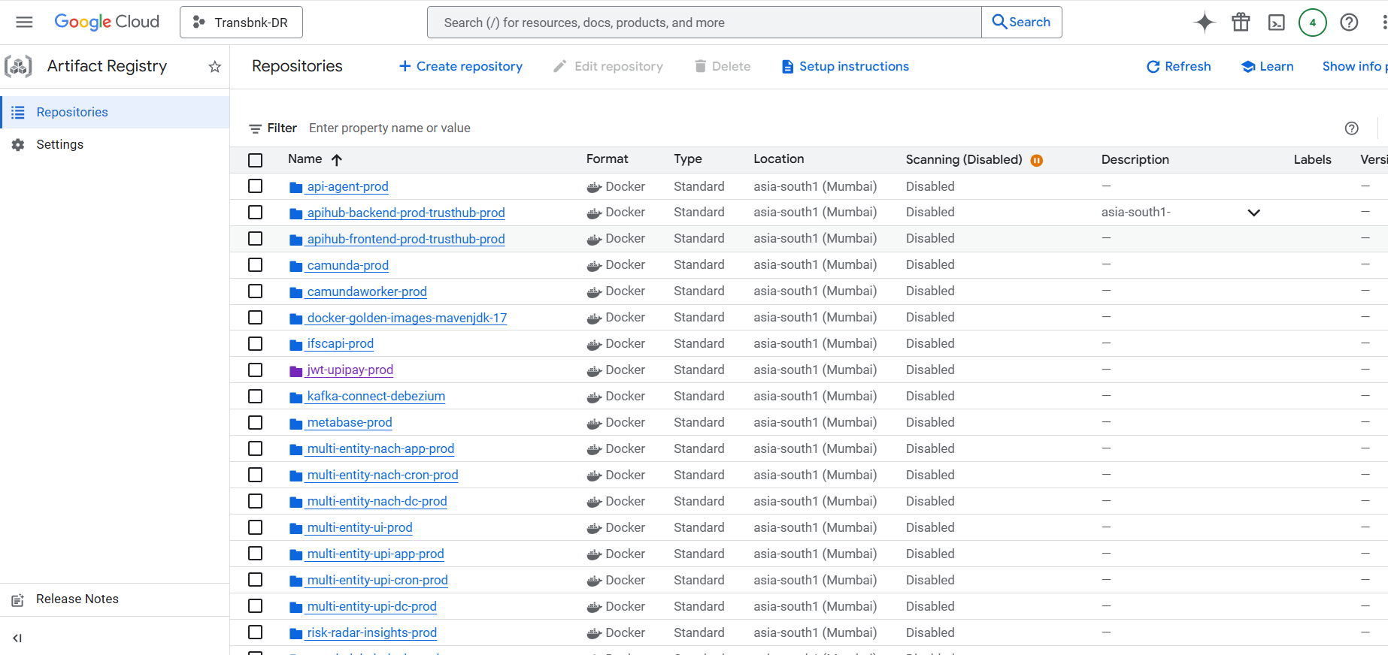

S3 Bucket migration
- For S3 migration, we used Storage Transfer Service
- Migrated AWS S3 buckets to Google Cloud Storage
- When we start create storage transfer job, first select the source type Amazon S3 and the destination type is Google Cloud Storage
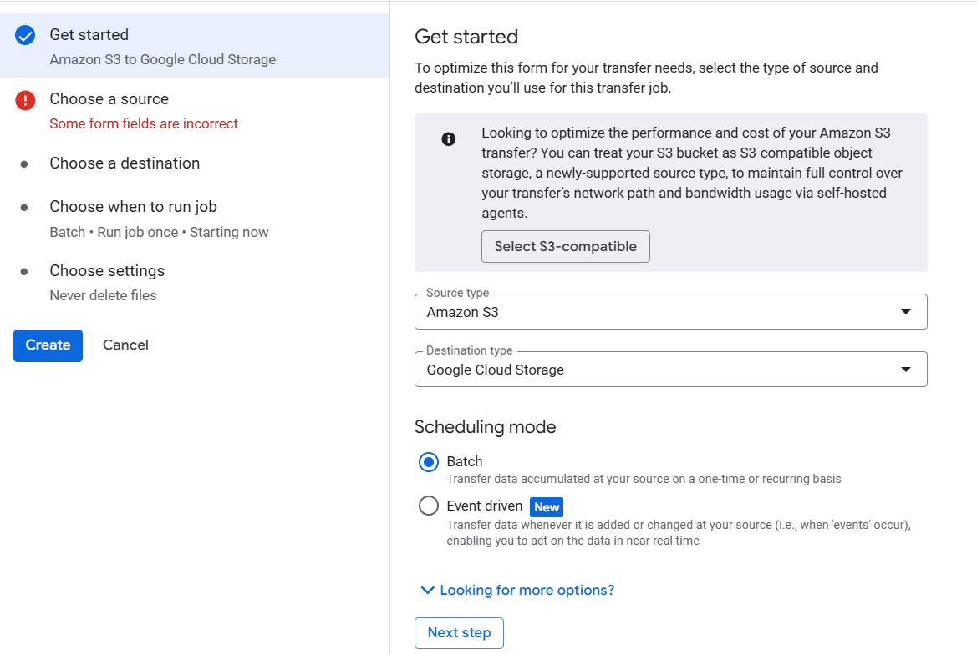
- For the source, you need to specify source details
Bucket name
Credentials: Access key and secret key
- 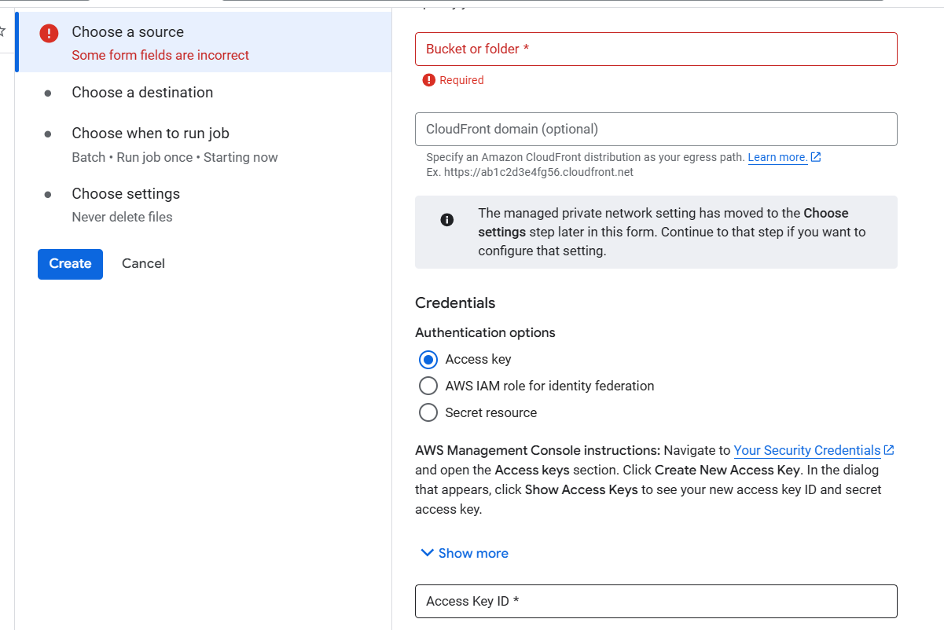
- After that, select the destination details like the bucket name
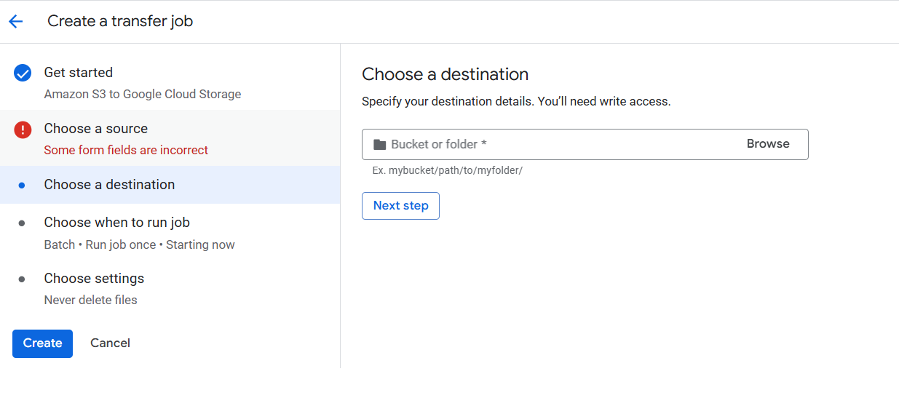
- Choose the run job type
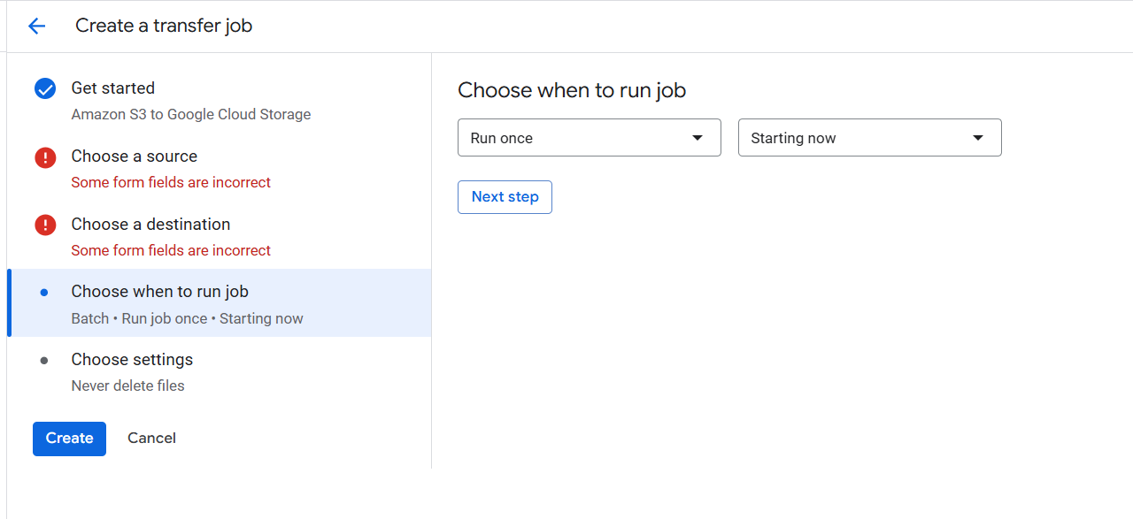
- After creating the job, run the job it will migrate bucket aws to gcp
- Right now, we created 28 jobs for bucket migrations
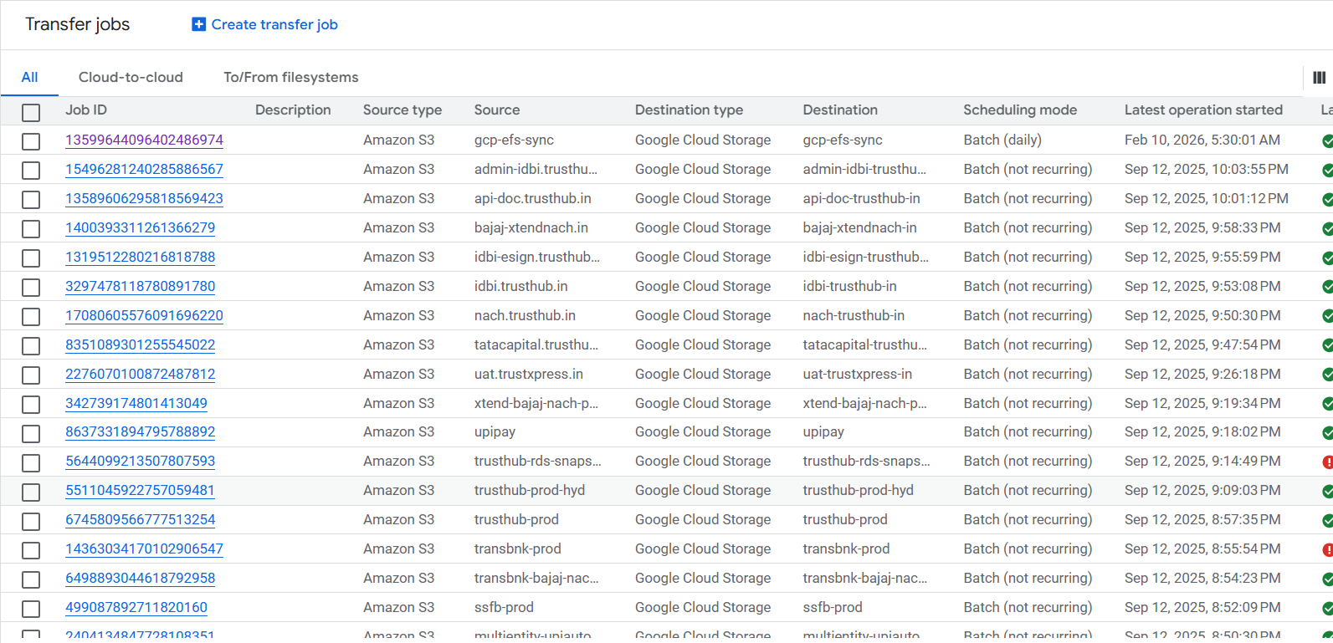

RDS MySQL to Cloud SQL using GCP Database Migration Service

1. Pre-migration requirements
- Ensure RDS MySQL version is supported by Cloud SQL
- Enable binary logging on Amazon RDS:
  - binlog_format = ROW
  - binlog_row_image = FULL
- Set binlog retention > migration duration
- Create a migration user in RDS with required privileges

2. Create Cloud SQL (MySQL) instance
- Create a Cloud SQL for MySQL instance in GCP
- Use the same or higher MySQL version
- Configure region, machine type, and storage
- Do not create databases/tables manually

3. Configure network connectivity
- Ensure DMS can reach RDS:
  - Allow RDS Security Group inbound access
  - Whitelist DMS public IPs or use VPC peering
- Open MySQL port 3306

4. Create Database Migration Service profile
- In GCP Console → Database Migration
- Create a Source connection profile:
  - Engine: MySQL
  - Endpoint: RDS endpoint
  - Username & password
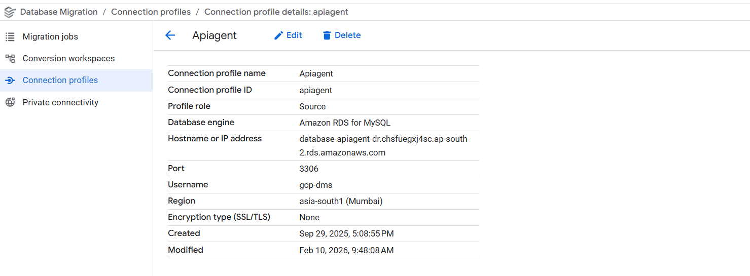
- Create a Destination connection profile:
  - Select the Cloud SQL instance

5. Create migration job
- Select migration type:
  - Continuous (minimal downtime – recommended)
- Choose Full dump + Continuous replication
- Select databases/schemas to migrate
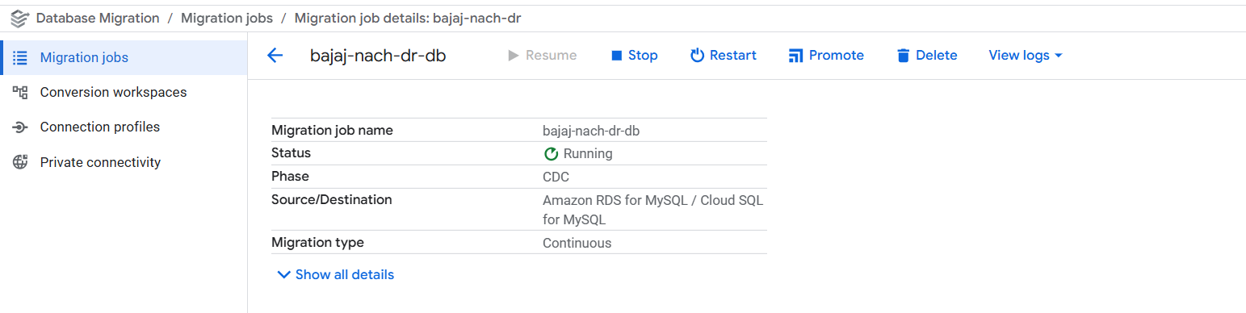

6. Start migration
- DMS performs:
  - Initial full data load
  - Ongoing replication using binlogs
- Monitor status in GCP Console
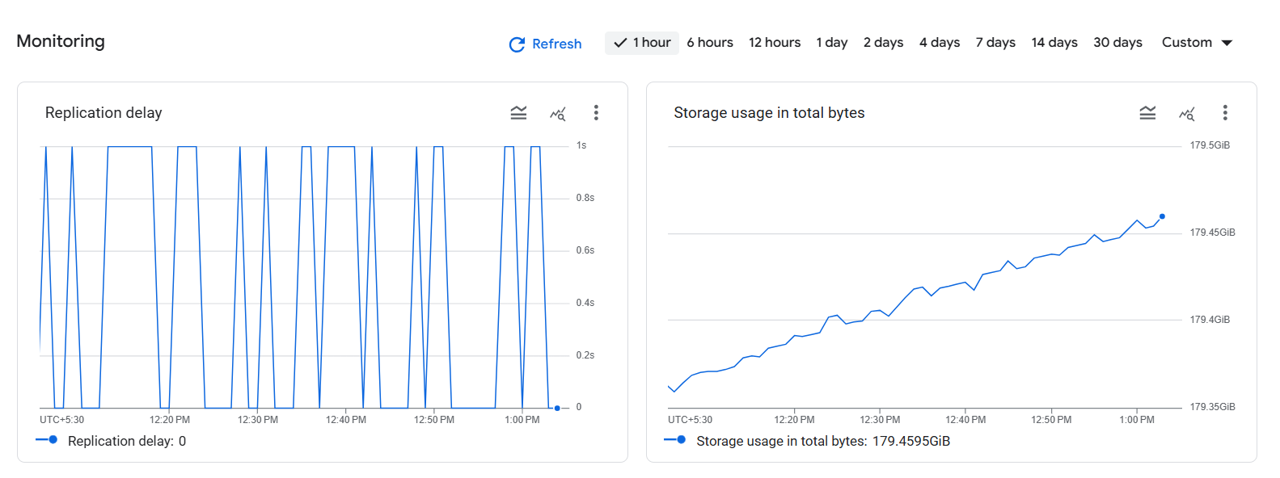
We created 9 jobs for DB migrations
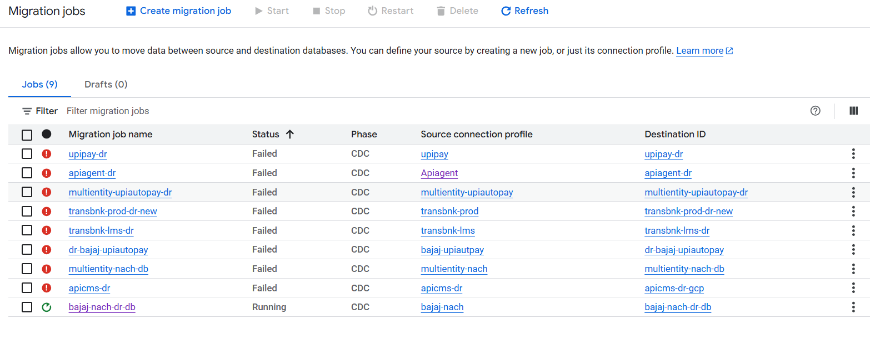

GKE Setup
- We created the two GKE cluster one trusthub-prod-eks-cluster and xtend-prod-gke-cluster
- Both cluster created on the asia-south1 location
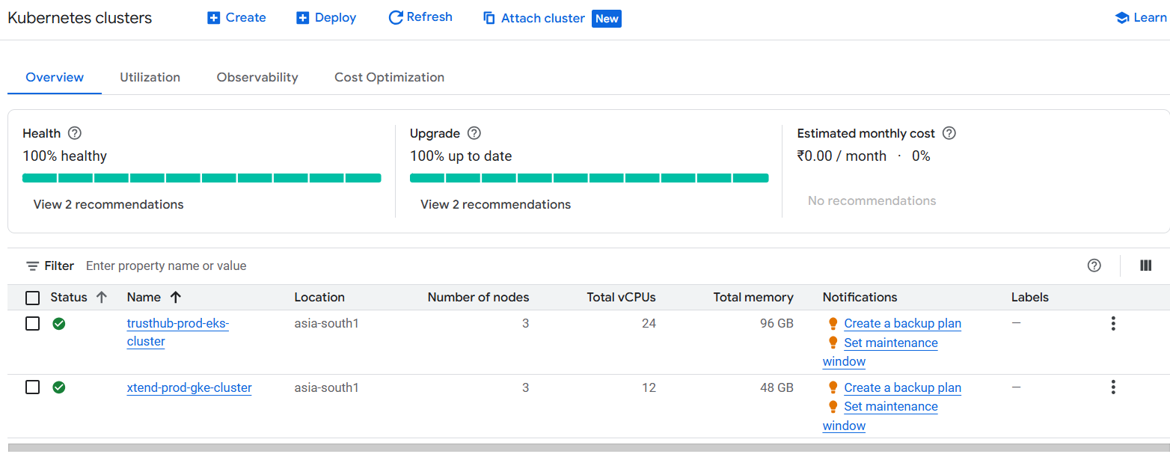
- 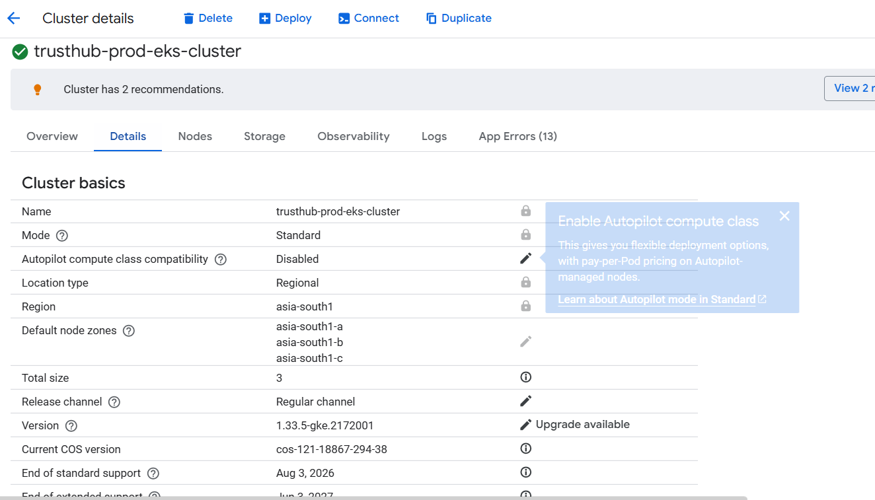
- 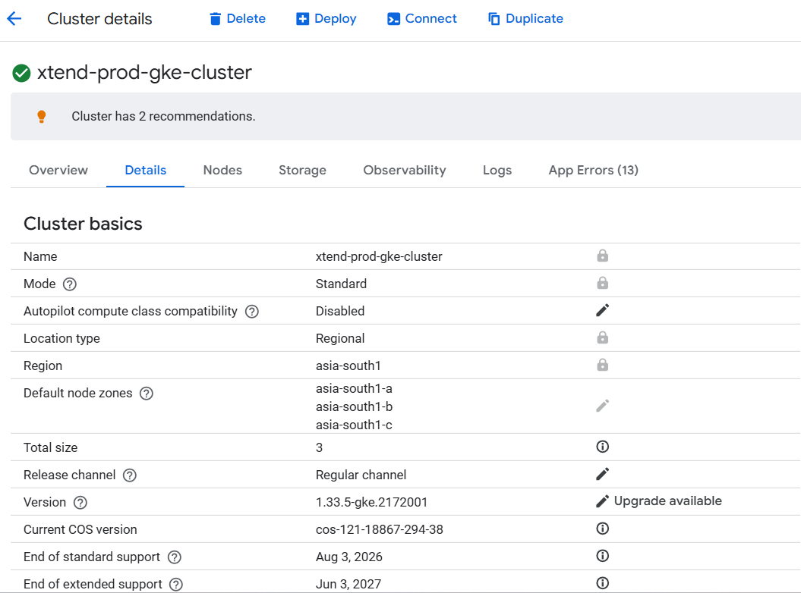

- Also, we createda jump host for the cluster connections
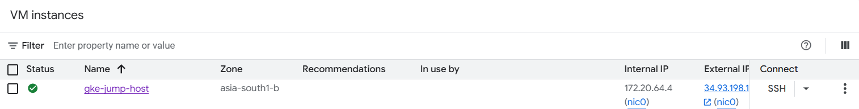
- And one more VM for Jenkins pipeline
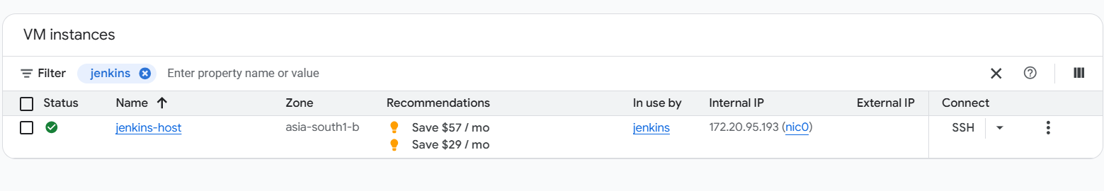

Connect to the cluster
- To connect to the cluster, first ssh to the jump host
- 

- After that, configure the cluster using the following command
gcloud container clusters get-credentials trusthub-prod-eks-cluster --region asia-south1 --project transbnk-dr
- 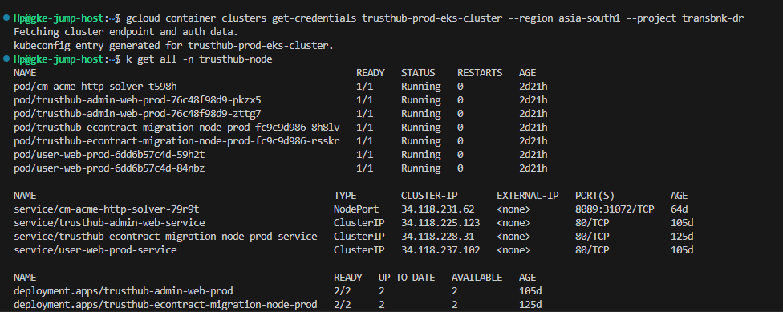

K8s Files
- All k8s files are available in the jump host
- Under the transbnk folder
- You can use the same jump host to connect to both clusters
- 